July 17, 2003

AFSCME Enterprise Application Project

Complex and Background Processing –

Base Reporting

Prepared by:


Contract: PSA No. 10571

Version 1.1

Table of Contents

Section 1 Purpose & Background 3
Section 2 Prologue 4
Section 3 Components 5
3.1 Report Access 5
3.1.1 Description 5
3.1.2 Design: Analysis/High Level Design 5
3.1.3 Use Cases: 6
3.1.4 Rational Rose Model: 6
3.2 Report Generator 8
3.2.1 Description 8
3.2.2 Design: Analysis/High Level Design 8
3.2.3 Use Cases 11
3.2.4 Rational Rose Model 11
3.3 Email Generator 13
3.3.1 Description 13
3.3.2 Design: Analysis/High Level Design 13
3.3.3 Use Cases 14
3.3.4 Rational Rose Model 14

Purpose & Background

This document records the output of requirements elaboration, analysis, and high-level design for Complex and Background processes within the Base Reporting Module of the AFSCME Enterprise Application.

Complex and background processing is all of the processing in a system which exceed the general processing of receiving user input, reading and writing data from a data source and presenting the results to the user. In a web based system, this is typically that processing which exceeds the general requirement of receiving an HTML based http request, processing the input (via a JSP or Servlet in our case), reading and writing to a data store and creating the response to a user. Complex means that the processing may exceed this typical action (request)-response model. Background relates to processing which is outside of the request-response model (such as that initiated by an external or system event), or processing which runs as a background process and is driven by a scheduler. For standard user interface processing (not considered complex or background) the UI action (request)-response pattern and/or components for assisting this pattern (such as a Model-View-Controller (M-V-C) component) may be described in the C&B processing document. However, the processing required for each screen/page in the system will not be.

The C&B processing document is organized by components. A component represents a subsystem or key reusable component of the system. Components may represent different levels of size or complexity, there are no constraints in these dimensions, however, components should be organized so that there is a “natural” interface between functionality provided as a service from one component to another.

Prologue

Provide a release version / date / author mechanism. Revisions tracked only for releases, not interim versions.

REVISIONS
Version | Description | Date | Approval
1.0 | June 14, 2002 version submitted for final approval and baseline | 6/14/02 | G. Schuler
1.1 | July 17, 2003 version updated for Design tracking issue #23 in preparation for Release 1 Iteration #1 testing baseline | 7/17/03 | G. Schuler

Components

The following sections describe the complex and background processing components for the Base Reporting Module. Rational Rose diagrams at analysis level are provided to illustrate the use cases, class participation information, and critical scenarios for each target component.

Report Access

Description
This component will provide database accesses against the data model for Base Reporting in the Enterprise database.

Design: Analysis/High Level Design
This component shall encapsulate the database access to Base Reporting data model. The Base Reporting module may also access other persistent data in the Enterprise database during various points. For example, the Base Reporting module may execute queries against member and affiliate data; the Base Reporting module may also access the Member’s Correspondence History data. These kinds of accesses will be done outside of “Report Access” component. Most likely, these kinds of database accesses will be done within each control class for each functional specification of the Base Reporting module.

Sub-components: None.

This component will use authentication and access control services provided by the Framework. These services include:
- retrieving required information about user roles;
- retrieving required information on “Select Fields” privileges within the user’s role, to determine a user’s access rights on various data fields for Base Reporting functionality. These are the only privileges which control a user’s access to fields for Base Reporting functionality.

The design of this component also relies on the features of the Framework module to control user’s access to Base Reporting functionality.

The following use case diagram illustrates the use of the Report Access component by other elements.

Use Cases:
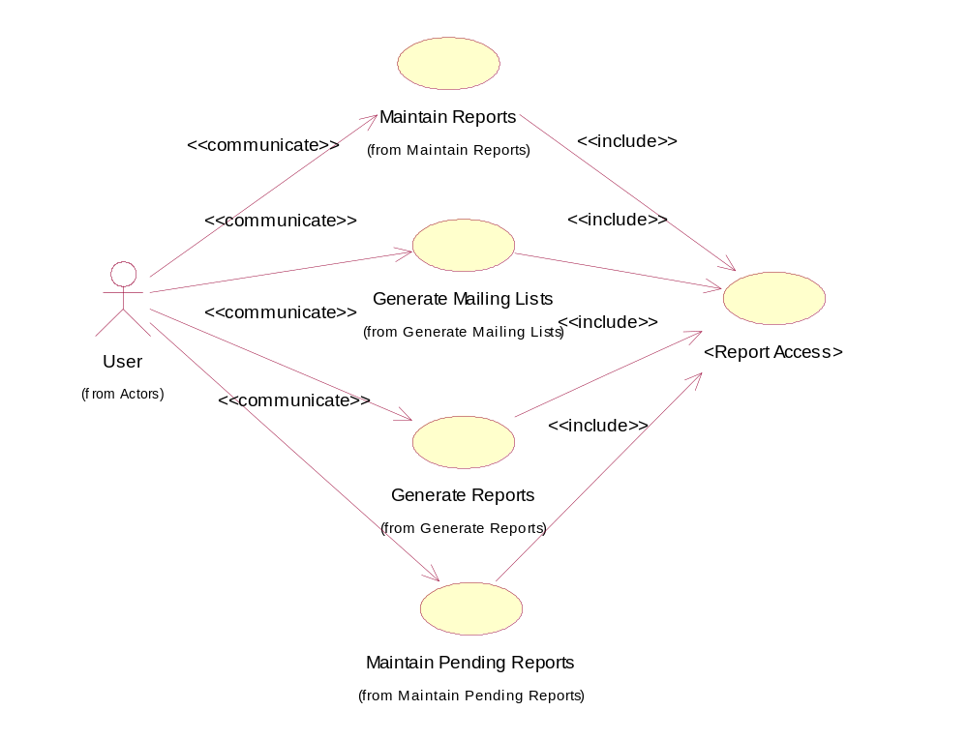
The precondition for this use case is that the system shall pass the access control check on whether or not the user can perform the functional specification for each actor of this use case. The high level services provided by this use case are shown in the following “participation” Rose class diagram.

Rational Rose Model:
The following diagrams show the participation of the “Report Access” component within the functional specifications of Base Reporting. For illustration purposes only, the diagram references example methods that would provide behavior related to this component.
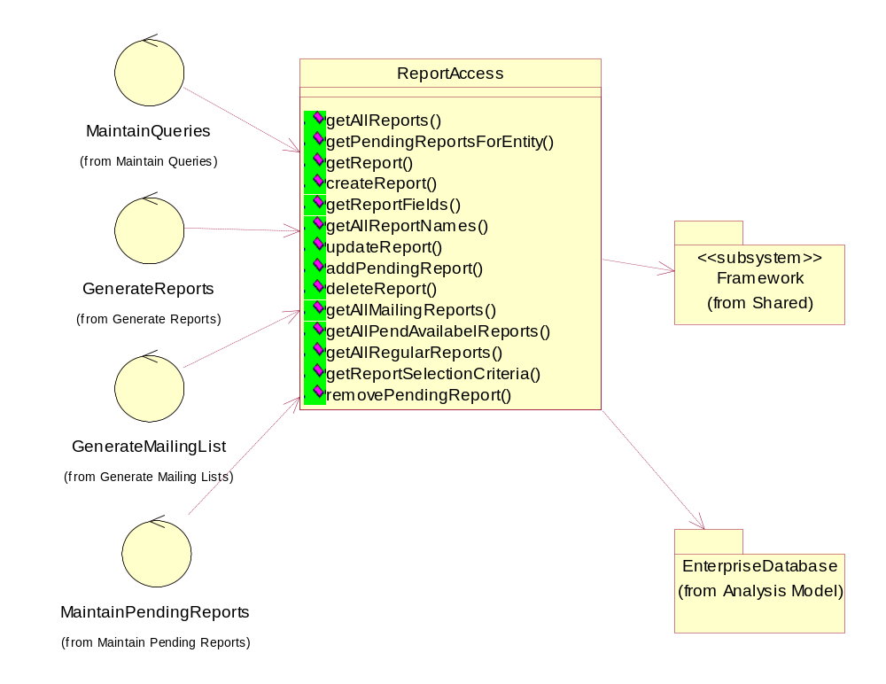

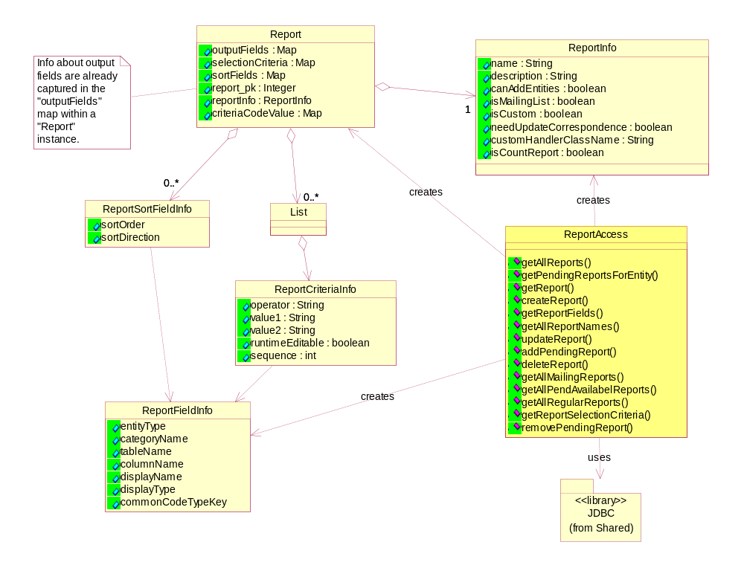

Report Generator

Description
This component will be responsible for generating the SQL statement for a report, executing the statement, retrieving the query result, and formatting the result with the user selected output format.

Design: Analysis/High Level Design
This component supports functionality required for both Generate Reports and Generate Mailing Lists functional specifications.

Sub-components:
- Report Formatter
  - Formats the report in selected output format.
- Title Processor
  - Inserts a title for each address from “Title For Mailing”, or “Prefix” fields if “Title For Mailing” does not exist.
- Duplicate Address Processor
  - Removes the duplicate mailing records; Combines mailing records with same addresses and different names.

Design Assumptions:
- The run-time selection criteria will not be saved as part of the report information in the Enterprise database.
- Address ID will be taken from the primary key of the address table. For person addresses, the ID will be prepended with 1, for organization addresses the ID will be prepended with 2.
- Postal Bar Code information will be just the zip code. No special processing is required in the Base Reporting module.
- Carrier Route information is already stored as part of the address record in the Enterprise Database.
- For PDF file output format, if the report is one of the specialized reports, the output format will be generated by the report specific code. If the report is a custom report, the content will be tabular.
- For a predefined output format, such as Label, certain fields in the database will be mapped to the output positions in the output format’s template. If the query result contains fields that are not in this list, the data will not be output as part of the output file.
- For “Mail Merge File” and “Mail House File”, the system will generate the Data Source file in comma-delimited ASCII text file. The system will send this file as an email attachment to a configurable email address.

The Report Generator component has a public subsystem interface realized by two types of implementers: “GenericReportGenerator” and “MailingReportGenerator”.
- GenericReportGenerator is used to generate regular reports.
- MailingReportGenerator is used to generate a mailing list report that has some additional tasks to perform. It is responsible for adding title information and removing duplicate addresses if it is instructed so. It is also responsible for appending additional query constraints if they are not already defined for the report during report creation. These constrains are: Sort by “Zip Code” and Sort by “Carrier Route”.

The major services provided by the “Report Generator” component are illustrated in the “participating class diagram” in section 3.2.4. The “Report Generator” will use in-memory report data for creating the corresponding SQL statement. That is, the calling component shall be responsible for accessing the “Report Access” component at some point prior to using the “Report Generator”. This prior activity may also include allowing the user to define/edit selection criteria before the report is generated.

The “ReportFomatter” has three kinds of implementers: DelimitedTextFormatter, LabelFormatter, and PDFFormatter.

DelimitedTextFormatter:
- Formast the report into an ASCII text file with one of the following delimiters:
  - Tab
  - Comma
  - Semi-Colon
- Report output will have column headings.

LabelFomatter:
- Formats the mailing list report into a specific label format defined below:
  - Each row will have four labels
  - Each page will have twelve rows of labels. That is, a page break will be inserted every twelve rows of labels.
  - Each label will be formatted as the following examples:

If “Officer Title” is selected:

PRESIDENT LOCAL 3889 55
JANITZA BERNIER
P O BOX 276
GUAYAMA PR 00785

Otherwise:

9924
DOROTHY R ZOLLNER
6408 BIRCHWOOD AVE
BALTIMORE MD 21214

  - The template is defined below:

If “Officer Title” is selected:

“Officer Title” “Affiliate Type” “Affiliate Code” “Affiliate State Code”
“First Name” “Middle Name” “Last Name”
“Address 1” “Address 2”
“City” “State” “Zip Code”

Otherwise:

“Member Number”
“First Name” “Middle Name” “Last Name”
“Address 1” “Address 2”
“City” “State” “Zip Code”

“Member Number” is whatever the primary key for a member record.

PDFFormatter:
- Formats the report into a PDF file.
- Report output will have column headings.
- Report Name and Description will be included in the output.
- Date Generated will be included on the header/footer of the report.
- The output file will have an AFSCME standard statement: “AFSCME proprietary and confidential information”.
- If the generated content is too wide for a standard page width, the system will wrap columns into multiple lines.

Use Cases
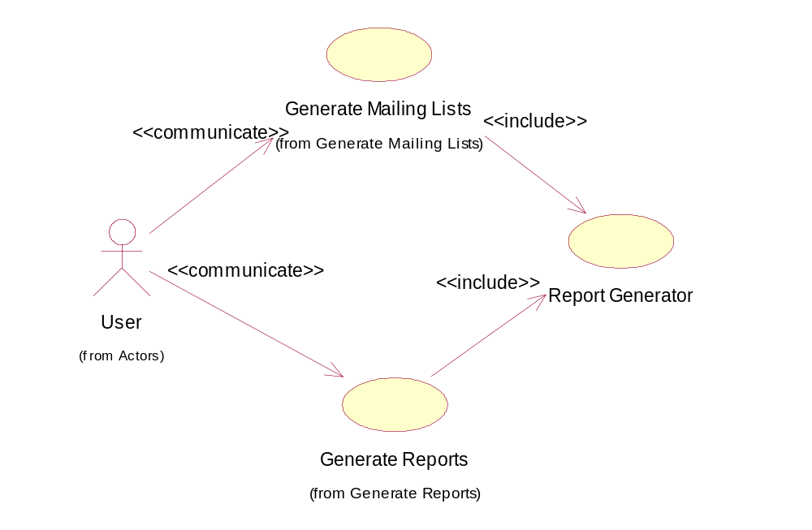

Rational Rose Model
The following diagram shows the relationship among the Report Generator component and its sub-components. The methods in this diagram are for illustration purposes only, in order to further describe the expected behavior supported by this component.
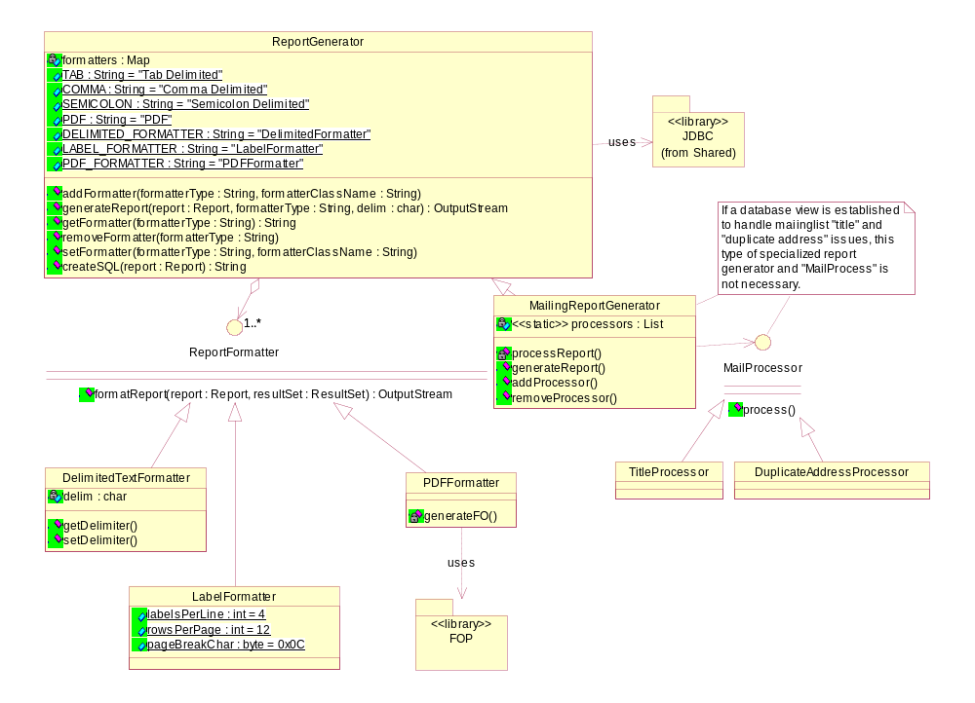
The following diagram is the participating class diagram.
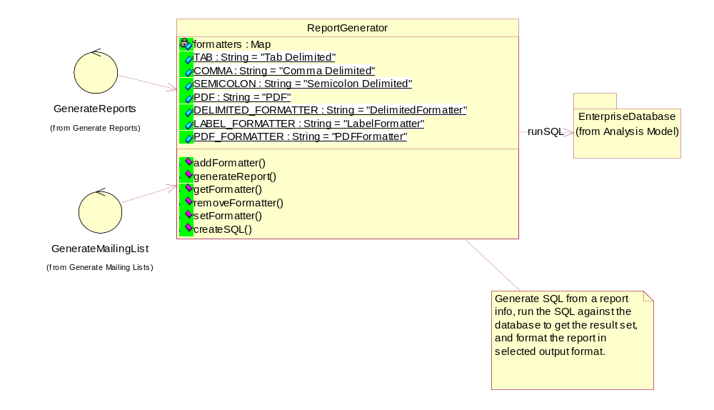

The following diagram displays a critical scenario where the “Report Generator” is involved in the “Generate Reports” functional specification, and an output format other than “Screen” is selected by the user:

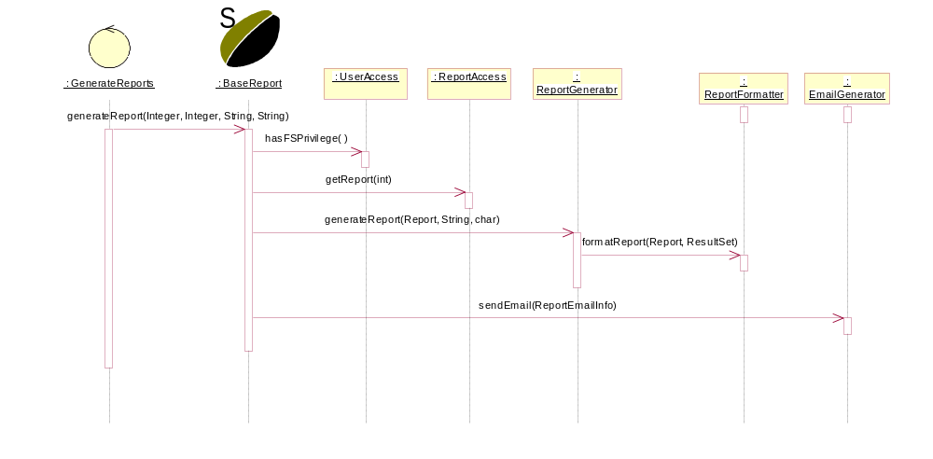

Email Generator

Description
This subsystem provides services to create and send emails for sending generated reports or for user notification. Email will be used to send reports whenever the output format other than “Screen” is selected.

Design: Analysis/High Level Design
This component will encapsulate the internal processing of creating and sending emails. SMTP protocol will be used in the implementation.

Sub-components: None.

Assumptions:
- Assume there will be a SMTP server at AFSCME’s Data Center, and it will handle email delivery.

Following is the email content and format:
Send To : the current user
Subject : Print report, CD report, Diskette report, Tape report, Mail Merge report, Mailing House report, or Label report.
Attachment : the generate report output file
Content :
For regular report:
The following report is generated for you:
Report Name, Output Format, Requestor User ID, Requested Time
For mailing list report:
The following report is generated for you:
Report Name, Output Format, Requestor User ID, Requested Time
The number of pieces of mail

Use Cases
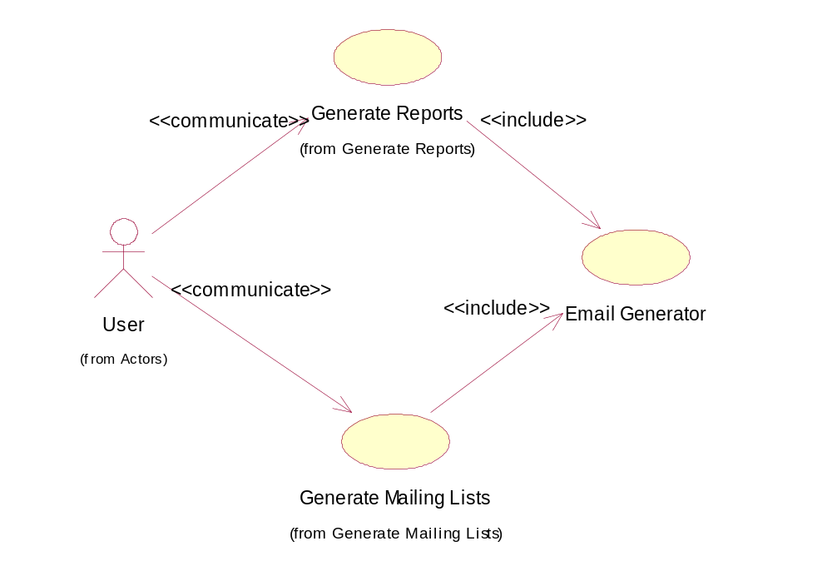

The pre-condition for this use case is that the output file is properly formatted with the selected output format.

Rational Rose Model
The following diagram shows the usage context class diagram for the “Email Generator” subsystem:
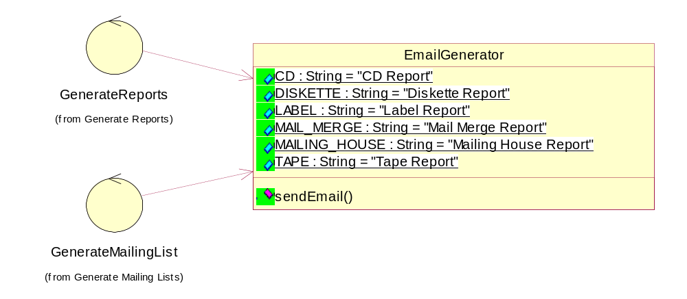

The following diagram is a class diagram for internal structure of this subsystem:
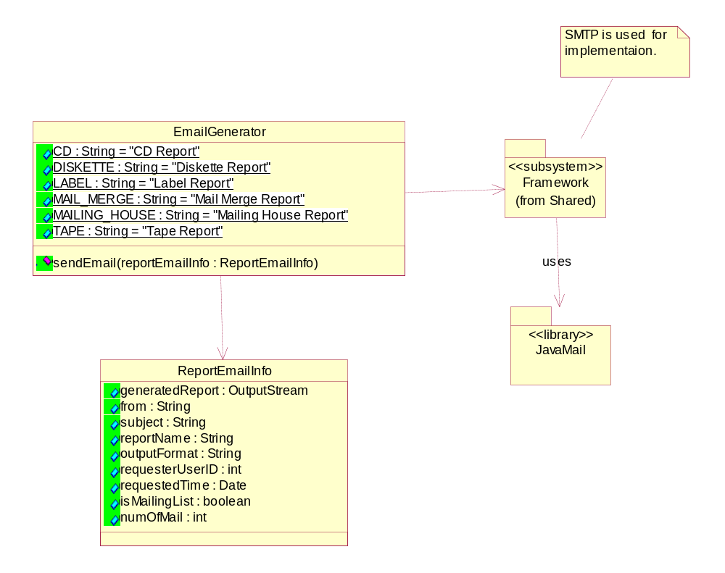
This actual use of this subsystem in a sequence diagram is already illustrated in the sequence diagram for “Generate Report” subsystem. Please refer to Section 3.2.4 for details.

